**Qu 1a.**

**Figure 1.** National summer burials in eighteenth century in England.

Summer burials vary for each year and I cannot see any specific pattern. In general, most of years are in range between 30 000 and 40 000 burials. In some cases, the records are significantly higher, as we can see in years 1727-1728 or 1783, where funerals reach the number 50 000.

**Qu 1b.**

**Figure 2.** The English summer burialsmortality index across years 1707-1792, also including the worst mortality years (index≥125).

The years with the highest mortality index are: 1719 (135.61), 1727 (137.58), 1728 (146.85), 1729 (126.14), 1741 (132.13), 1773 (136.53) and 1783 (131.28). The top crisis mortality took place in the year 1728 and the second highest index year before – 1727. The year 1729 also shows above average values, and therefore we can assume some connections between those three continuous years.

**Qu 1c.**

The figure 1 illustrates gradually increasing trend for summer burials numbers whereas the figure 2 is relatively stable with occasional significant growths. In my opinion the figure 2 is more objective and precise as considers 15-years moving average.

**Qu 2.**

**Figure 3.** Number of summer deaths as z-scores in Gloucestershire during the years 1770-1795. Values are calculated from the months July, August, and September only.

We can observe three years where z-scores are 0, what indicates no difference from the mean value (3). The year 1783 represents a crisis mortality event, as a z-score is greater than 2. There is not any other period of that high value. The remarkable fact is, that the year before this one, identifies 0 z-score value, and year after even negative values. Behind this sharp increase must be some reason with high magnitude. From the graph we can observe repeating pattern, in which specific z-scores continuously stay around the same value across three or more years. The ratio between the positive and negative values is not significant, however values below the mean are slightly more pronounced, what indicates lower mortality rate.

**Qu 3.**

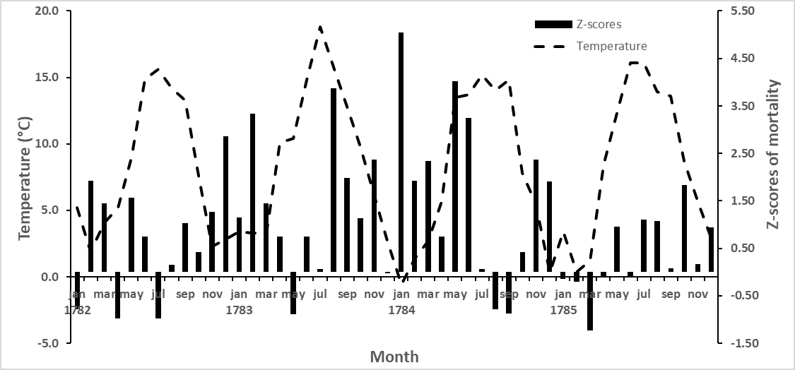

**Figure 4.** The monthly (1782-1785) mortality z-scores for the parish of Blunham in Bedfordshire and the central England temperature data from Manley’s (1974) record.

There is a clear relationship between mortality and temperature - the highest mortality is still in winter when temperatures are the lowest. Moreover, in January 1784 the temperature drops on -0.6°C and caused the sharp boost in z-score value (5.044). The increased mortality values continue until the March when the air become warmer.

**Qu 4.**

The Laki (or Skaftár Fires) eruption began on June 8, 1783 and continued until Feb. 1784. It is considered as one of the largest volcanic eruptions in recorded history. The 8 months of lava flows and explosions that ejected an astounding 14.7km3 of basaltic lava that run out of 140 vents along a 23 km long set of fissures and cones (Grattan at al., 1995).

The damaging effect of the volcanic haze and fallout of very fine ash had a serious impacts on the whole Iceland. Sulfur dioxide emitted from the lava flows stayed in relatively small distance to the ground (within 5 km) and created strong acid rains which easily irritate skin, burn holes in leaves and kill trees and shrubs. In some areas, 60% of grazing livestock died in less than a year, mainly from chronic fluorosis (Thordarson, 2003). But more importantly, the famine and disease resulted from eruption and killed over 10 000 people (~22% of the population) in Iceland (D’Arrigo et al, 2011).

At the global scale, around 95 megatons (Mt) of sulfuric dioxide entered the upper and lower troposphere, so also the jet stream which transported these particles around the entire northern hemisphere. The westerly jet stream at altitudes <15 km is the most common for Icelandic eruptions and shows the eastwards dispersal from the source (Jónsson, 1990). Ashfall’s reports show that the eruption plumes travel to mainland Europe up to 50 hours when following meandering waves within the jet stream and in 16 hours when following the straight path. This indicates mean transport velocities of 15 to 18m/s (Thorarinsoon, 1949).

The arrival of haze to Europe makes it one of the greatest disasters of the past millennium - just in Britain are estimated ∼23,000 deaths from gas fumes. The precise cause of these deaths remains unknown, but many people are certain that dying in unusual numbers had something to do with the hot sulphurous fog (Grattan and Brayshay, 1995). Huge number of people feel seriously ill with symptoms that are associated with chronic air pollution (Durand and Grattan, 2001). The magnitude of the event can have a profound influence of populations far from an eruption – the hot summer air temperatures in July 1783 in England (see. Fig 4) became the hottest ever recorded, probably due to released volcanic gasses (Grattan and Sadler 1998). The poor air quality and high air temperatures in combination, is a modern lethal environmental cocktail (WHO, 2004). But can we blame the influence of the volcano for this all?

The paper by Grattan et al. (2007) stressed that how important is to consider the vulnerability of cultures and environments rather than the magnitude of the eruption itself. It is unobjective to identify only a single environmental vector. The figure 2 shows a slightly higher values of mortality for the year 1783, but this also happened several times in history, so nothing special?... The health context in 1783 revealed threats such as fevers, epidemics, malaria, smallpox, scarlet fever or water-borne enteric illness posed and ever-present threat to the weak, the elderly and even to the young (Grattan, 2007). Moreover, Creighton (1965) described the events of 1783 as “The Epidemic Agues of 1780-1785”, because of high resilience of agues to treatment by Peruvian bark. In 1783 intensified an influenza epidemic – a killer in the 18th century. Examples mentioned above are just a fragment of the possible mortality caused factors in the England.

The great Laki eruption had marked effects on the

atmosphere and the environment in the Northern Hemisphere

in 1783 and 1784.

The great Laki eruption had marked effects on the

atmosphere and the environment in the Northern Hemisphere

in 1783 and 1784.

The great Laki eruption had marked effects on the

atmosphere and the environment in the Northern Hemisphere

in 1783 and 1784.

The great Laki eruption had marked effects on the

atmosphere and the environment in the Northern Hemisphere

in 1783 and 1784.

The great Laki eruption had marked effects on the

atmosphere and the environment in the Northern Hemisphere

in 1783 and 1784.

Although Thordarson et al. (2003) are convinced that the great Laki eruption had marked effects on the environment and atmosphere in the Northern Hemisphere in 1783-1784, there is contradictory study proving something else. The research by D’Arrigo et al. (2011) posed a question if the dominant cause of the anomalous winter of 1783-1784 was truly Laki eruption, or rather a combined negative phase of the North Atlantic Oscillation (NAO) and an El Nino-Southern Oscillation (ENSO) warm event. To test this alternative explanation, case-study used proxy-records, observations, and models if a negative NAO-El Nino, as in 2009-2010 were able to cause the same winter conditions as of 1783-1784, without the Laki’s eruption. Winter during 2009-2010 broke records not only over western Europe, but also in eastern North America. These snowy and cold conditions were attributed to a mentioned NAO and El Nino. The double combination cooperates where an El Nino cause increased snow as enhanced storms impact central-southern latitudes of the U.S., while the NAO add sufficient cold for the precipitation to fall as snow. 600-year tree-ring reconstruction of NAO and ENSO indicators reveal values in the 1783-84 winter second only to their combined severity in 2009-2010. Furthermore, paleo-index had the second highest score of the past 600 years in 1783-1784, with the most severe in 2009-2010. Model simulations and data sources support the hypothesis that negative NAO-ENSO warm phase was the dominant cause of the anomalous winter of 1783-1784. Therefore, events such as famine, crop failure and livestock loss likely resulted from natural variability unconnected to Laki (D’Arrigo et al., 2011).

To what extent the Laki eruption influenced climate, the environment, and human health is for now debatable. Our world is a sophisticated system with uncountable mechanisms that are necessary to preserve equilibrium. Therefore, this requires an approach with focus on a consideration of cultures and environments in detail rather than in abstract (Driessen, 2002).

**References**

Creighton, C (1965) A History of Epidemics in Britain, vol 2, Cambridge, Cambridge University Press

D’Arrigo, R, Seager, R, Smerdon, JE, et al. 2011. The anomalous winter of 1783–1784: Was the Laki eruption or an analog of the 2009–2010 winter to blame? *Geophysical Research Letters* 38: L05706.

Durand, M and Grattan, JP (2001) ‘Volcanoes, air pollution and health’, The Lancet 357, 164 Gentleman’s Magazine, The. A monthly serial published 1731–1914

Grattan, J.P. and Brayshay, M. 1995: An amazing and portentous summer: environmental and social responses in Britain to the 1783 eruption of an Iceland volcano. *The Geographical Journal* **161**, 125-134.

Grattan, JP and Sadler, J (1998) ‘Regional warming of the lower atmosphere in the wake of volcanic eruptions: the role of the Laki fissure eruption in the hot summer of 1783’, Geological Society Special Publication 161 Volcanoes in the Quaternary, 161, 161–72

Jónnson, T., Dispersal directions of volcanic plumes from Icelandic eruptions., 60, 103-105, 1990.

Thorarinsson, S., The eruption of Hekla 1947-48-The Approach and beginning of the Hekla Eruption, *Soc. Sci. Isl., Spec. Publ., 2*, 1-23, 1949.

Thordarson, T, Self, S (2003) Atmospheric and environmental effects of the 1783–1784 Laki eruption: A review and reassessment*. Journal of Geophysical Research* **108**, D14011.

Thorarinsson, S., The eruption of Hekla 1947 – 48—The Approach and

beginning of the Hekla Eruption, Soc. Sci. Isl., Spec. Publ., 2, 1– 23,

1949

World Health Organisation (2004) Heat waves, risks and responses, Geneva WHO